|  |  |  |
| --- | --- | --- |
|  |  | Session 1  **Basics of Raspberry PI and Linux** |

AOLME Curriculum Level 1

# Goals

1. Explore, identify, and name a computer’s components across systems (PC and Raspberry).
2. Describe how information flows in a computer system.
3. Utilize basic Linux commands to navigate filesystems in a Raspberry Pi.
4. Practice assembling components and cables of a computer system.



## Activities:

**1.1. Components of a computer and the Raspberry Pi**

**1.2. Assembly of the Raspberry Pi components and internal data flow in Computers**

**1. 3. Navigation of directories and basic commands in Linux**

Each activity includes 1 or 2 cards. One side of the card is in Spanish and on the back the same information is in English. Each card has 4 quadrants, each quadrant includes a task related to the main goal of the activity. The numbers in the square on the left describe the order to perform the tasks. The card must be at the center of the table. Students need to have access to it and take turns reading it. They can read it in the language they feel more comfortable.

1

2

3

4

# Components of a computer and the Raspberry Pi

## Activity 1 Goal:

Explore, identify, and name a computer’s components across systems (PC and Raspberry).

## Resources for the Activity

* Activity Card
* 3 decks of cards (white, yellow, green) with names, definition, visual of computer parts
* Raspberry Pi
* Old real-life computer
* Student journal

## Interactions

In this activity students are to think about the components of a computer. It is important that they recall what they remember from their prior contact with computers. Always use their experiences as a starting point and then build on ideas. While in the guidelines for this activity there are four tasks, these tasks only describe ideas and how they can be processed. Throughout the activity provide a friendly environment, supporting the participation of everyone. Notice who participates more or less and pay attention to why it might be and act on it, so participation can be more even from everyone. Support at all times the use of the language (Spanish or English) that the students want to use.

## Activity 1 Card:

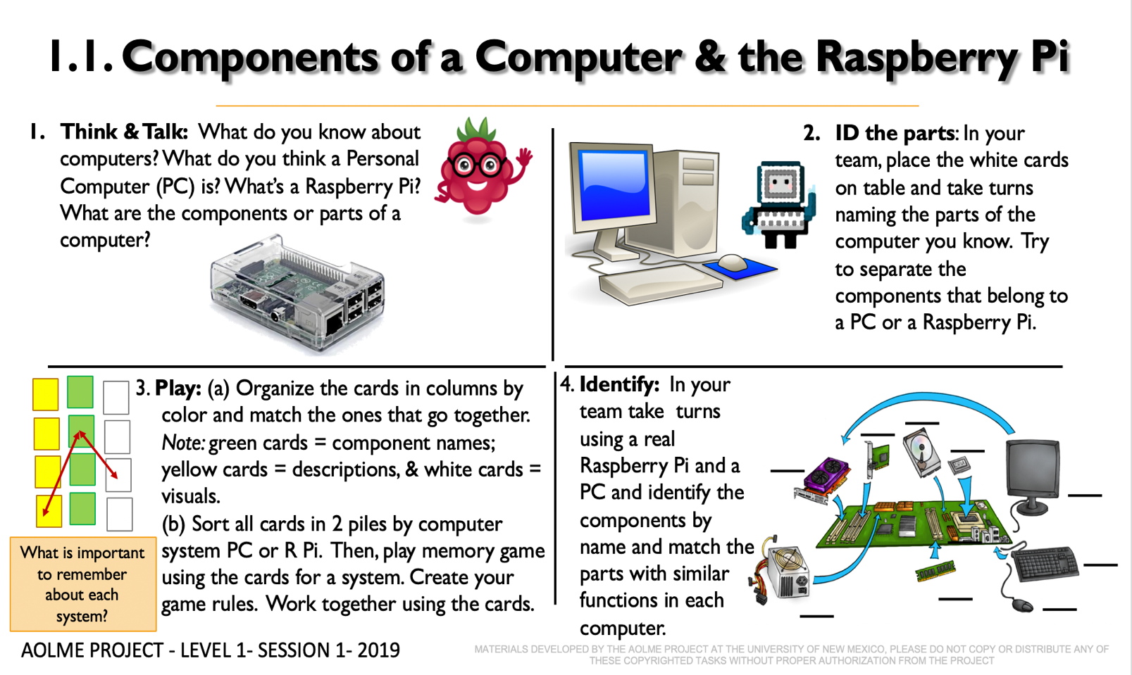

## Recommended Steps for the Activity

## Task 1: Have students have an informal conversation about computers that can lead to recalling the names of the parts of a computer. Do not lecture, talk about it.

## Task 2: Use a real computer to ID those parts. Use similes or examples of real life to describe the parts/components.

## Task 3: Before playing the memory game, make sure students (mostly on their own) accurately connect the names, visuals, and descriptions of the parts. Have students practice these links by playing memory. Make it less about a competition and focus on understanding. Check if words in cards make sense. Make it fun! Have students make decisions on how to play the game.

## Task 4: Have students lead the making connections across computer systems. Use the Raspberry Pi!!

**Content: Introduction to Computers**

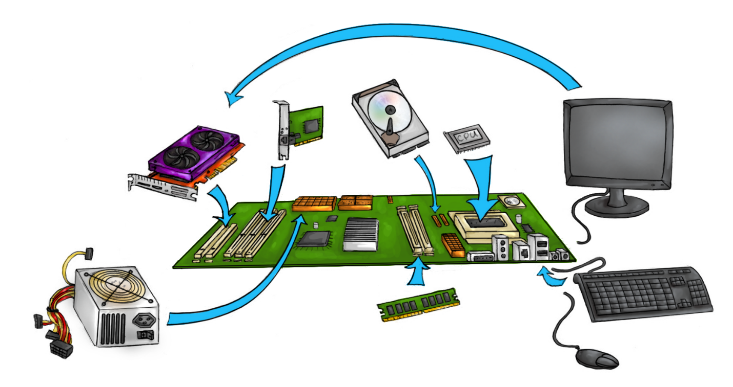The figure below shows the **components** inside a Personal Computer (PC). Components work together to make the PC function. The image below shows where each part is plugged into the **motherboard**. ***Where is the motherboard in the picture?***

Monitor

These are the major components of a personal computer:

1. **Monitor** outputs or shows what the computer is doing.
2. **Video Card (GPU) is a** tiny chip that processes the display of images.
3. **Processor (CPU) (3)** acts like the brains of the computer.
4. **Power Supply** receives and distributes power of the computer and components.
5. **RAM** a flat stick of circuits that holds the working memory.
6. **Ethernet Controller** receives and sends data from/to the Internet.
7. **Hard Disk Drive (HDD)** has the Operating System and stores files on computer.
8. **Mouse** “looks” like a mouse and inputs information and commands through clicks.

**Keyboard** serves to input information by using special characters.

**The Raspberry Pi** is a tiny computer that has components that work the same way as a PC’s components do, but they look different.

In the Raspberry Pi, because it’s so small, most of the **components** are built into the **Motherboard**. In a PC, components can be upgraded, but not in the Raspberry Pi. ***Why do you think that is?***

The Raspberry Pi has only two removable parts: the **SD micro card** that stores the operating system and files, and the **Camera** thatyou can use to take pictures or video. If you find any of these in your Raspberry Pi, share it with your team.

# Assembly of the Raspberry Pi components and internal data flow in Computers

## Activity 2 Goals:

(a) Describe how information flows in a computer system.

(b) Practice assembling components and cables of a computer system.

## Resources for the Activity

1. Activity Card
2. Raspberry Pi kit per group
3. Power strip
4. Monitor

## Interactions:

Throughout the activity, provide a friendly environment, supporting the participation of everyone. Notice who participates more or less and pay attention to why it might be and act on it, so participation can be more even from everyone. Support at all times the use of the language (Spanish or English) that the students want to use.

## Activity 2 Card:

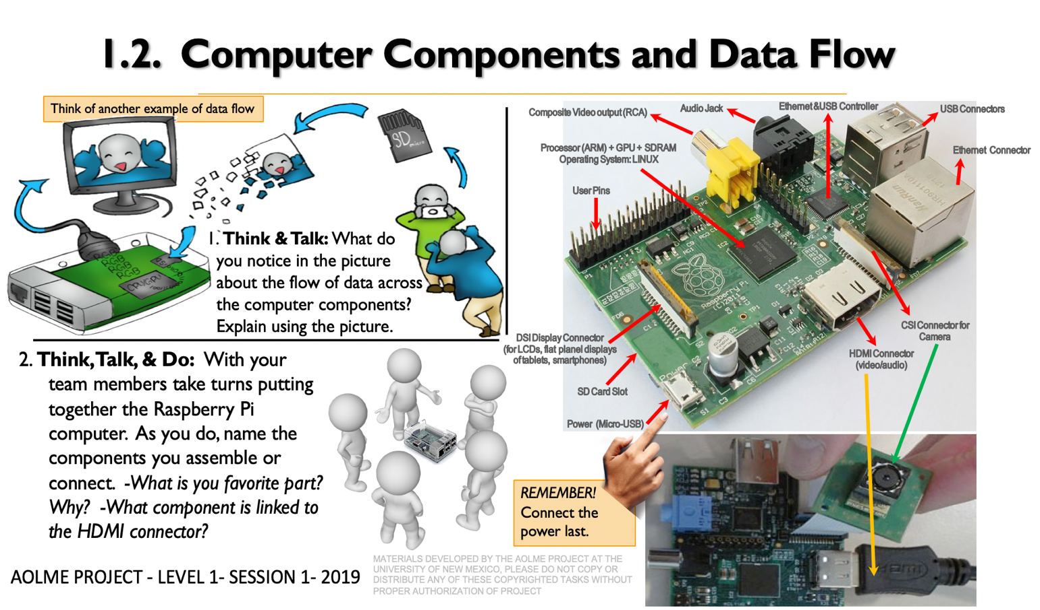

## Recommended Steps for the Activity

## Task 1: Have students describe the illustration of taking pictures as an example of data flow and create a story-like about the data flow. Elaborate on data flow ideas by having them further think about their own experiences at school using data on a computer.

## Task 2: Motivate students to use the names of the components of the computer as they talk. Model that type of talk to them as the team puts the computer system together.

## Make sure all students participate in the assembly and ask them to describe using related vocabulary on what they are doing or how they connected those parts.

## Have students describe their own experiences assembling computers at home or school.

## Ask for any questions they might have and encourage team members to respond.

**Content: Data Flow in a Computer System.**

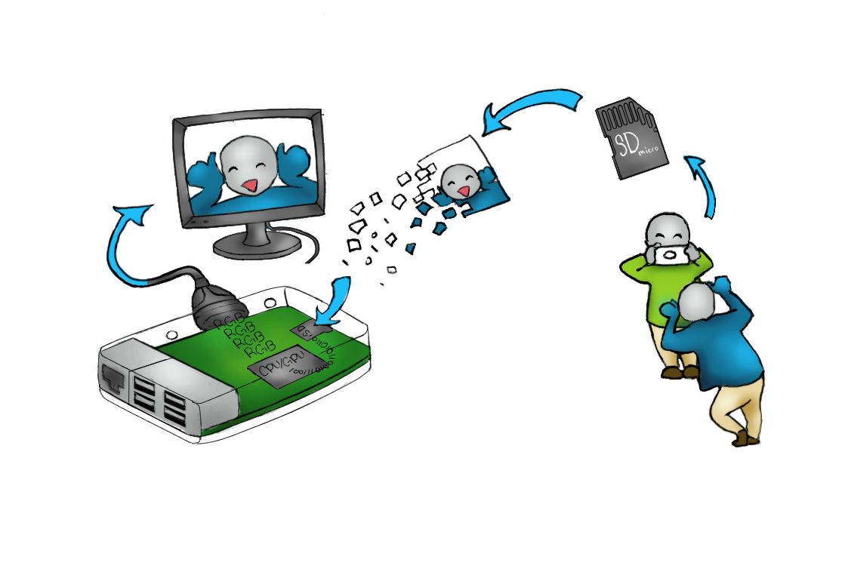Information, or data, has a flow in a computer system. In the Raspberry Pi, the picture you take of a friend has its path to be displayed onto the monitor. It happens after the image is converted into an electronic file.

The illustration above shows how a picture transfers from your camera onto the computer monitor. The camera saves the image of your friend sticking his tongue out onto an SD card, then when the card is inserted into the computer. Next, the Processor reads the image information and sends it to the GPU. This component translates the image information and outputs it onto your monitor.

# Navigation of directories & basic commands in Linux

## Activity 3 Goal:

Utilize basic Linux commands to navigate filesystems in a Raspberry Pi.

## Resources for the Activity

1. Activity Card
2. Raspberry Pi kit
3. Student journal

## Activity 3.1 Card:

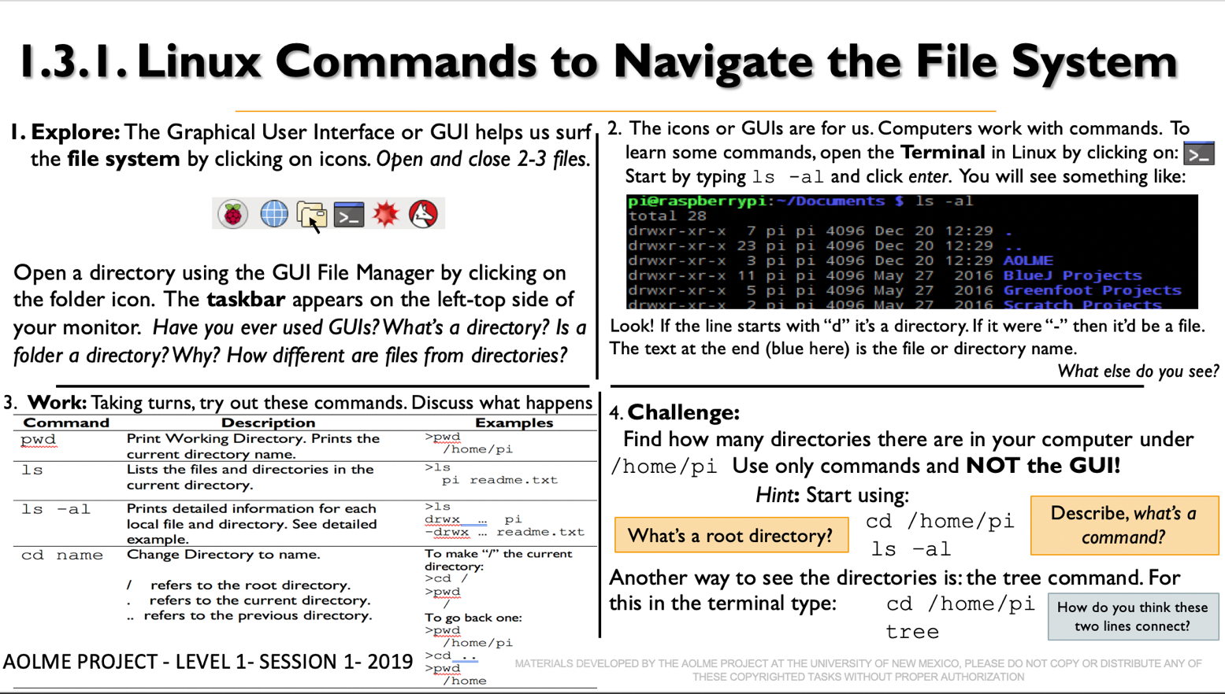

## Recommended Steps for the Activity:

**Task 1:** Using terms (directory/file), have students think about how they usually navigate computers and use that to think about this session.

**Task 2:** Compare with them how the terminal is similar of different from GUI. Expand the idea of directory and compare it with everyday things they know.

**Task 3**: Motivate students to take turns typing in commands, so that all of them have similar participation. Let students pay attention to what is happening when commands are typed and ask those who are not typing to describe what is happening and why. If the group wants, create own names for directories. Promote collaboration by listening to and helping each other. An error is just a step to get better.

**Task 4:** This challenge helps students review what they learned in the session: navigate and Linux commands. Ask your group to think about the directory levels linked to the ls -al & tree commands. Discuss how they are similar to or different from each other. Link the tree command to an actual tree and find connections think about the organization of a directory. Ask students to note the link between the /home/pi line and the ‘tree’ command and imagine changing names of directories and talk about what this link does. If there is time, run tree commands with other directories.

**Content:**

We just used the command called “Change Directory” or cd. A **directory** is list of folders contained in another folder, it shows your File System. We are in the Documents directory, but don't know its content, yet. To see it, we need another command. The List command (ls) will list the content in the folder.

* Type **ls –al** and hit Enter (Then you can see this:)

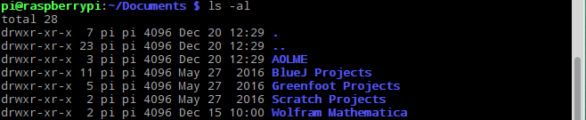

In the list, do you see the name AOLME? AOLME is the name of a folder in the Documents folder. If you wanted to go to the AOLME folder, you:

* Type **cd AOLME** and hit Enter

If you wanted to go back to Documents from AOLME, you:

* Type **cd ..** and hit Enter

Now, use some of the commands we learned to explore these directories.

***What do all those letters in the black box mean?***

When you listed the contents in the Document folder, a lot of words or codes came up. Let’s break it down. The text in purple refers to a **Directory**. Pink text represents a **file**. The white text represents the following:

Owner’s permissions

Group permissions

Everyone else’s permissions

Owner

Group (for permissions)

File or Directory Name

Last modified date and time

Size

“Links”

**drwxr-xr-x 2 pi pi 4096 Dec 20 12:29 AOLME**

Owner is the computer user that created the file.

“d” means that this is a directory (a folder) that contains other files. If the “d” is missing, then this is a regular file.

“r” means that the computer allows you to read the file.

“w” means that the computer allows you to overwrite the file.

“x” means that you can run this as a program, but it will not work unless it is

a program.

Note that everyone else refers to other users that we want to disallow from “w” and possibly “x” permissions.

Look at the top of the ls –al printout.



Here we can see a single dot and two dots. These are **Directories** because they are in purple font. Since they are directories, use the cd command to see what they do.

*Need a hint? . is the current directory level you are in and .. is the previous directory.*

## Activity 3.2 Card:

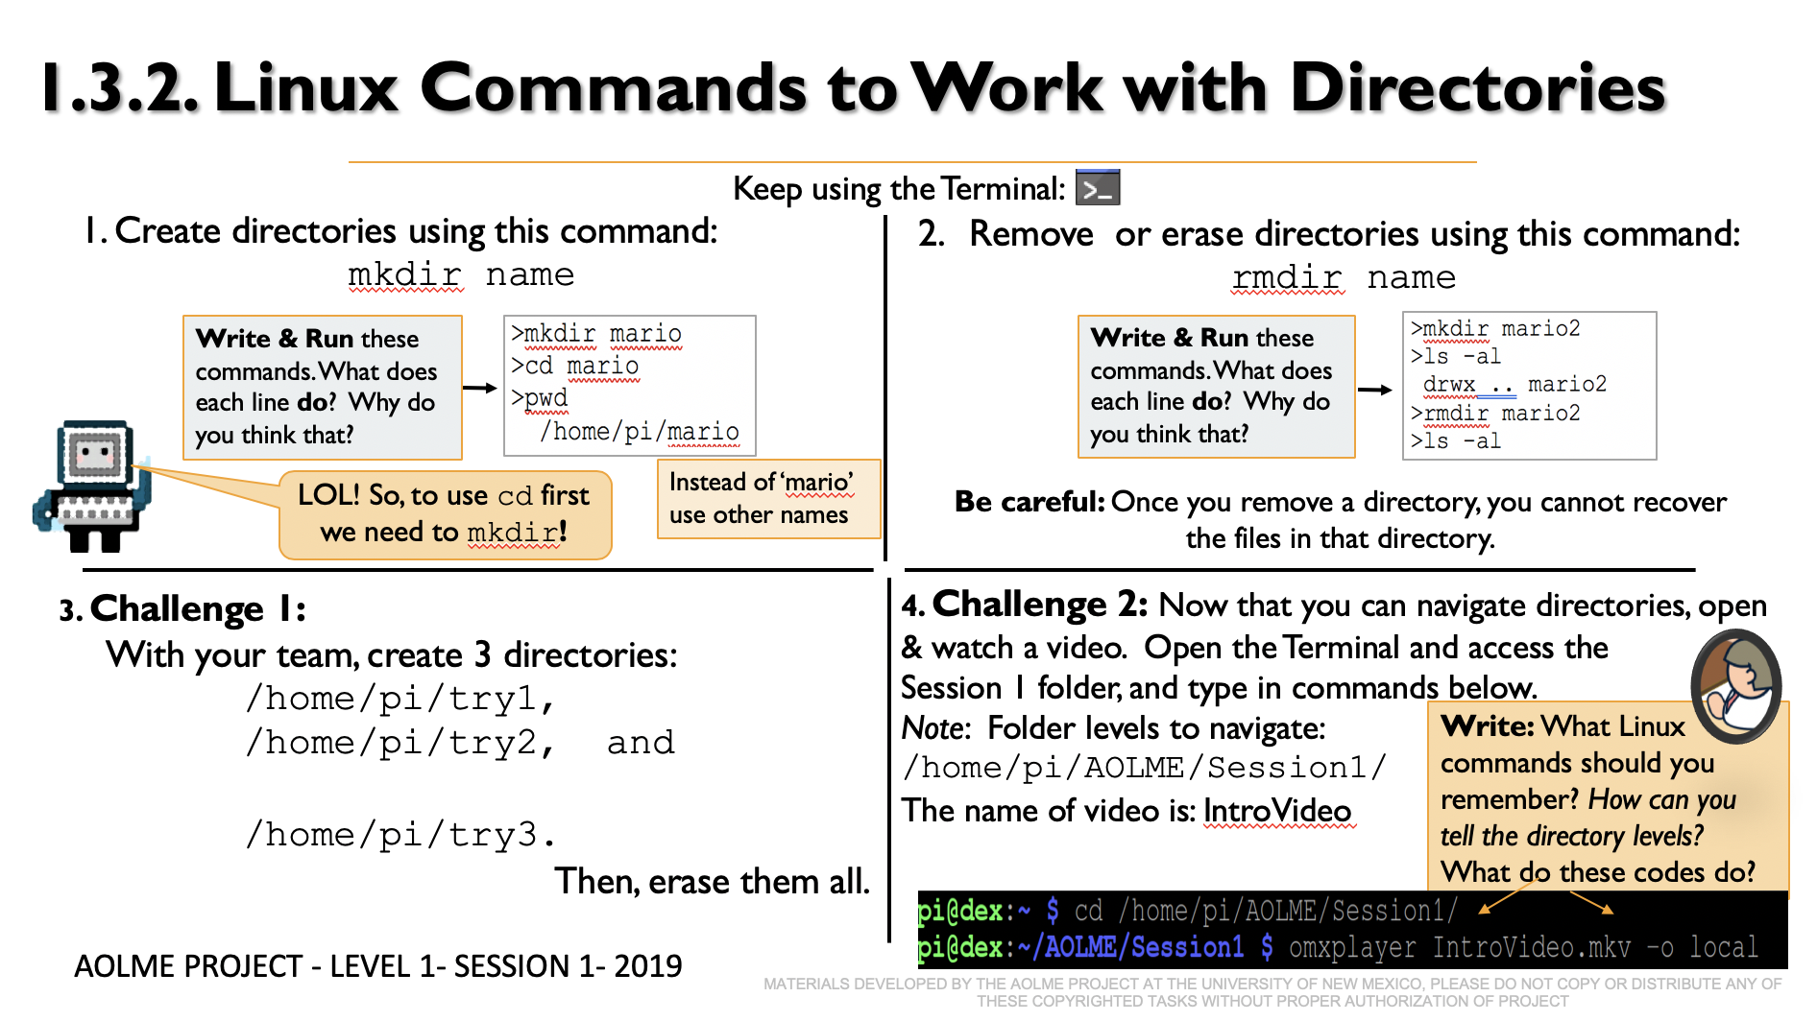

## Recommended Steps for the Activity

**Tasks 1 & 2:** Motivate students to take turns typing in commands, so that all of them have similar participation. Let students pay attention to what is happening when commands are typed and ask students who are not typing to describe what is happening and why. Go line by line and have them write in their journal.

**Task 3**: Promote collaboration by listening to and helping each other. Ask students to re-visit their notes on tasks 1 and 2 and apply ideas here. Promote the use of vocabulary like directory. An error is just a step to get better.

**Task 4:** At the end, have students debrief what they learned at the end of the session. Ask students write in their journal at least 3 thoughts of what they learned in the session. Use cards 1, 2, 3.1 and 3.2 as prompts.